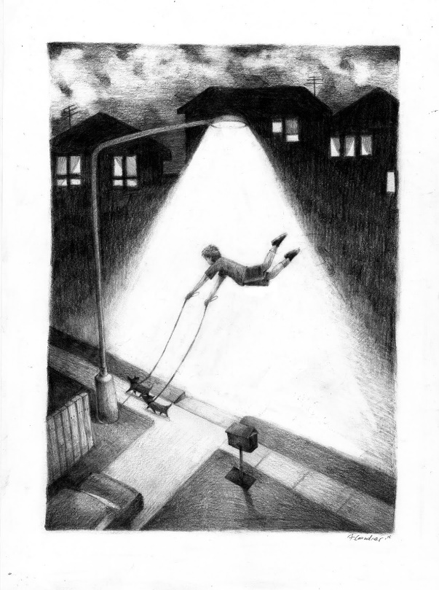1] (Remember, 150 words minimum.)

2] What is the best movie of all time? Explain why.

3] Write about whatever you want.